SQL CLASS -

TOPICS – WHERE Clause

Where Clause -

- To fetch the rows from the table that satisfy one or more conditions we use the where clause.
- In the where clause, we specify a search condition to filter rows returned by the from clause.
- Where clause only returns those records which satisfy the search condition to TRUE.
- Search condition can be a logical expression or a combination of multiple logical expressions.

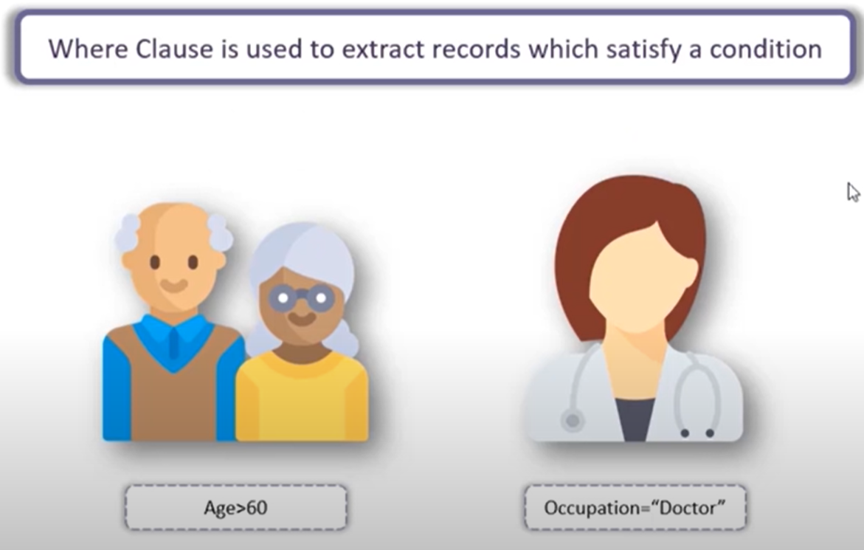

Syntax –
SELECT column_list FROM table_name WHERE search_condition;

Example –

CREATE TABLE vendors
(
vendor_id NUMBER,
vendor_name VARCHAR(100),
vendor_country VARCHAR(100),
vendor_price NUMBER
);

INSERT INTO vendors VALUES (1,'ABC Corp', 'India', 10000);
INSERT INTO vendors VALUES (2,'M-net','Bangladesh', 15000);
INSERT INTO vendors VALUES (3,'ABC Corp', 'South Africa', 10000);
INSERT INTO vendors VALUES (4, null, 'Russia', 21000);
INSERT INTO vendors VALUES (5,'Synergy','USA', 29000);
INSERT INTO vendors VALUES (6,'M-net', null, 31000);
INSERT INTO vendors VALUES (7,'Synergy','Egypt', 45000);
INSERT INTO vendors VALUES (8,'Synergy','USA', 10000);
INSERT INTO vendors VALUES (9,'M-net', null, 5000);
INSERT INTO vendors VALUES (10,'Synergy','Angola', 54000);
INSERT INTO vendors VALUES (11, null, 'India', 65000);
INSERT INTO vendors VALUES (11, null, 'USA', 48000);

Finding records using a single filter condition –

SELECT * FROM vendors WHERE vendor_id = 1;
SELECT vendor_id, vendor_name, vendor_country FROM vendors WHERE vendor_name = 'Synergy';

Finding records using a multiple filter condition –

SELECT * FROM vendors WHERE vendor_id = 1 AND vendor_name = 'ABC Corp';
SELECT vendor_id, vendor_name, vendor_country ,vendor_price FROM vendors WHERE vendor_name = 'Synergy' AND vendor_country = 'USA';

Finding records using comparison operator –

SELECT * FROM vendors WHERE vendor_id > 1;
SELECT vendor_id, vendor_name, vendor_country,vendor_price FROM vendors WHERE vendor_name = 'Synergy' AND vendor_price > 10000 ;

Finding records with 2 satisfying condition –

SELECT vendor_id, vendor_name, vendor_country FROM vendors WHERE vendor_name = 'Synergy' OR vendor_price > 10000;

Finding records with between 2 ranges –

SELECT vendor_id, vendor_name, vendor_country, vendor_price FROM vendors WHERE vendor_price BETWEEN 9000 AND 55000;

Finding records for a list of values –

SELECT vendor_id, vendor_name, vendor_country, vendor_price FROM vendors WHERE vendor_id IN (2, 3, 5, 6, 7);

Finding records for string value –

SELECT vendor_id, vendor_name, vendor_country, vendor_price
FROM vendors WHERE vendor_name LIKE '%Syn%’;

__________________________THANK YOU____________________________

